**CSE 3902**

**Sprint 4 Reflection**

**Group Loading…**

Group Members: Ben Roth, Sean Burns, Alex Quedens, Jiayi Pu, Diya Adengada

[Trello Board](https://trello.com/b/b2owSuhc/3902)

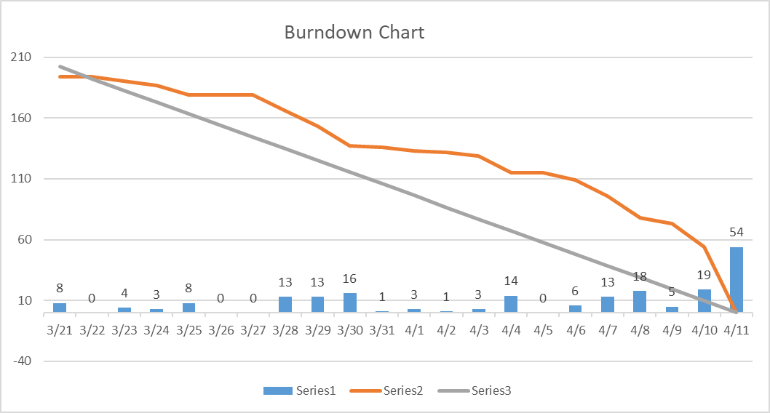

Overall, our team did pretty well on this sprint and was able to complete the majority of the tasks on our Trello board. We had a wider range of tasks to complete in this sprint, rather than focusing on a few key concepts, so we were able to break this up and work independently on a lot of components. Due to this sprint being much bigger than previous sprints, we were unfortunately unable to complete everything we wanted to, but we did as much as we could and hope to complete what was missing during the next sprint. A few times, we had a couple of merge issues but were able to resolve them quickly and get our project fully functional. We weren’t able to do a Code Review for this sprint, so we plan on doing one next time to ensure our code quality is up to the expected standard. Also, if there are any issues with the structure of our code, we will be able to fix them before the final deadline for the project.